Configuration Test for SAS Enterprise Guide Courses
To participate fully in the SAS Enterprise Guide course, it is necessary to have the following software installed and configured on your laptop:
- Base SAS (version 9.4, 9.3 or 9.2)
- SAS/GRAPH
- SAS Enterprise Guide 6.1
- Internet Explorer
- Adobe Acrobat
- Microsoft Word and Excel

For a complete list of all system requirements, please visit http://support.sas.com/documentation/installcenter/en/ikeguidesr/66619/PDF/default/sreq.pdf

The following steps will test the configuration of the components needed for class. Successful completion of this test will best ensure your full participation in the demonstrations and exercises:

- Load the course data onto your machine. You may save the data in any location on your computer. You should see the following folders and files in the EG151 directory:
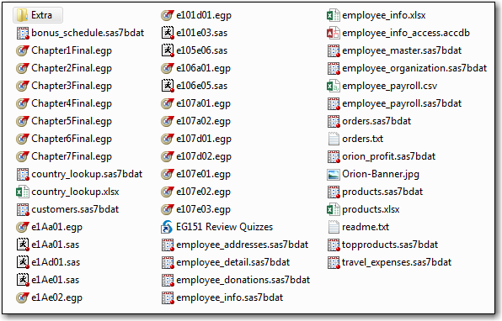
- Open SAS Enterprise Guide. If Enterprise Guide was installed to the default location, it can be started by selecting Start ⇨ All Programs ⇨ SAS ⇨ Enterprise Guide 6.1.
- Open the Test Configuration project
  - In the Welcome to SAS Enterprise Guide window, select More Projects…. Or if the Welcome window does not appear, select File ⇨ Open ⇨ Project….
  - Navigate to the location of the EG143 folder. Select Extra ⇨ Test Configuration.egp ⇨ Open.
- Determine your SAS Server name.
  - The Server List window should be open by default in the bottom left of the interface. If it does not appear, open it by selecting View ⇨ Server List
  - Expand the list of servers. If your server is named “Local”, skip to step 5. Otherwise, complete the steps below.
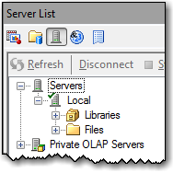
  - Select Tools ⇨ Project Maintenance. Select OK when prompted to close the project.
  - Under Servers, select Local.
  - Select Replace in Project.
  - In the Replace SAS Execution Server window, choose the name of your SAS server and select OK.
  - Select OK to exit the Project Maintenance Window.
- Run the Test Configuration project
  - Run the Project by selecting Run ⇨ Run Project at the top of the Process Flow window.
  - Once the project has run, double-click the Summary Statistics icon in the Project Tree window. Click each tab to verify the SAS Report, HTML and PDF results were created.

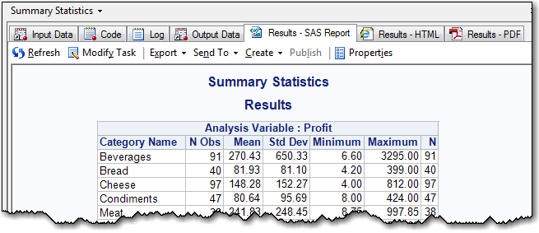

  - Click on the Output Data tab and select Send To -> Microsoft Excel. Verify the data opens in Excel, then close Excel without saving.

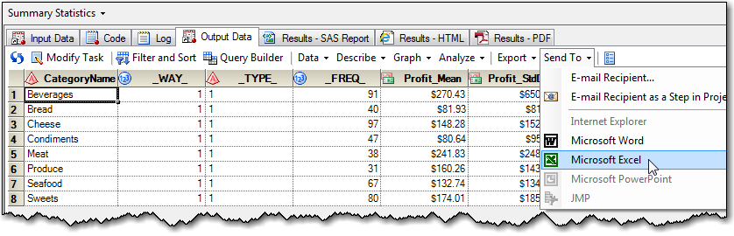

  - Double-click the Bar Chart icon in the Project Tree window. The results should appear as follows:

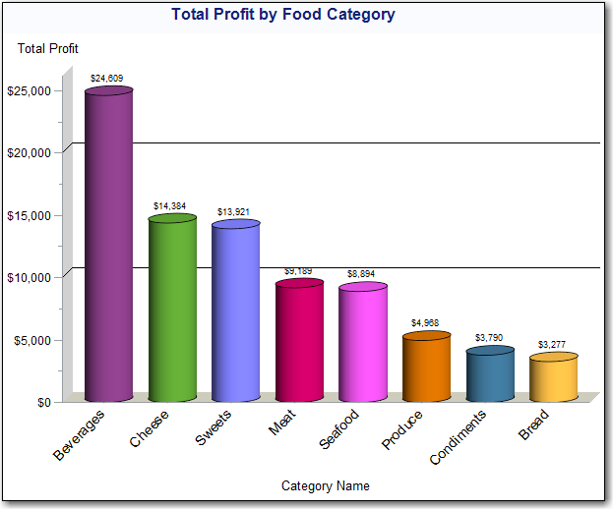

If all results are created successfully, your machine is prepared for class. If any of the steps do not render the same results shown in this document, please work with your SAS contact to verify that you have all the required software installed and configured.

