In this project the basic use of Hibernate will be presented
- Start a new NetBeans project with a preferred name, package name and main class.
- Include the required hibernate 4.x libraries
  - Expand your project in the Projects pane, and right click on Libraries.
  - Select add Library and add Hibernate 4.3.x
  - Result:
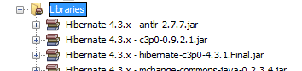
- Using the Hibernate Configuration Wizard add hibernate.cfg.xml to you rproject
  - Right click on your project
  - Select New -> Other ->
(Category: Hibernate, File Type: Hibernate Configuration Wizard)
  - Leave the name as it is and on the next page create a new database connection (by default Derby is selected).
  - The configuration for the new connection is:
    - Driver: Oracle thin, ojdbc6.jar (available on the page of the class)
    - Host: db.inf.unideb.hu, Port 1521, SID: ora11g
    - Use your own login information
    - Finish the setup (Next-next-finish)
  - In the Design view of hibernate.cfg.xml under Optional properties, Configuration properties add hibernate.show_sql: true
  - Under Miscellaneous Properties add hibernate.hbm2ddl.auto create (Later you can set this property to validate in order not to recreate the DB, just use the existing.)
  - Check the Source view of your config file:
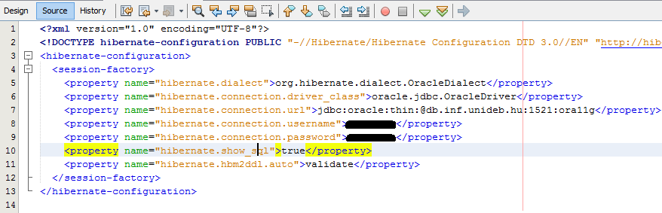

- Add HibernateUtil.java file to your project. Under a new package hibernate.db.
Use Right click on the project -> New -> (Category: Hibernate)
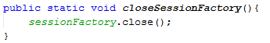
Add an extra method to the class:

- Create a new Class under the hibernate.model package (the subpackage is not yet created). The name of it is Animal and it has the following properties:
  - gender (enum MALE/FEMALE),
  - age (int),
  - name (String),
  - id (int)
Add getters and setters to these fields. Also add a default constructor.
- Use persistence annotations to create the animal entity
  - Use @Entity and @Table(name = “animal”) on the Animal class
  - Use @Id, and @GeneratedValue(strategy = GenerationType.AUTO) on the id field
  - Use @Column(name = "…", unique = … , nullable = false) on all fields. Set unique to true for the id, and for false for the other fields.
- In the hibernate.cfg.xml file under Mappings add the Animal class. The following line is added in the source:
- In the main method create a new hibernate session using the HibernateUtil class
- Instantiate a new Animal and save it to the database
  - Instantiate and initialize the animal object.
  - Save the animal using the code below:
session.beginTransaction();
session.save(elephant);
session.getTransaction().commit();
session.close();
HibernateUtil.closeSessionFactory();
- Check the new data appearing in the database
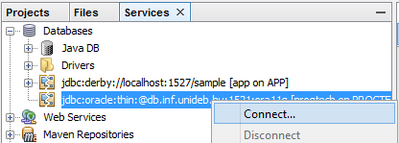

Advanced project:
- Create a DAO (Data Access Object) class for the Animal class
  - Create a new class under the hibernate.db package name: AnimalDAO
  - Make the class implement the AutoCloseable interface
  - Open a new Session in the constructor, and close it in the close() method
  - Add simple transaction methods to add, delete and update Animal objects
  - Add a method to get all the saved animals. Use the code below:
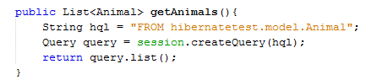
Read this for more about Hibernate Query Language: http://www.tutorialspoint.com/hibernate/hibernate_query_language.htm
- Modify the main method so that it uses the new DAO class for DB operations
Advanced project 2 - Mapping collections:
- Add a Zoo class to your project. A zoo has the following fields: id, name, animals. This latter field is a Set of animals held by the zoo.

- Annotate the Zoo class to be the zoo entity. Use the following annotations on the animals field:
- In the main method instantiate a new Zoo class and add an animal to it. Save the Zoo. Note that the Animal table also has been updated.
----------------------
- Modify the Zoo class by removing the animal field and the depending methods from it.
- Add a new field to the Animal class. Name it owner_zoo. The type is Zoo.
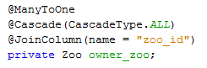
- Use these annotations on the field:

- Create an animal and a zoo. Set the owner_zoo field of the animal. Persist the animal.

See more about Hibernate associations:
http://viralpatel.net/blogs/hibernate-one-to-many-annotation-tutorial/

